**Q2) What is the difference between cat and more command?**

Cat:– Quick view for small files, shows the entire file immediately, without pauses.

Output scrolls straight to the end, handy for short files or combining files together.

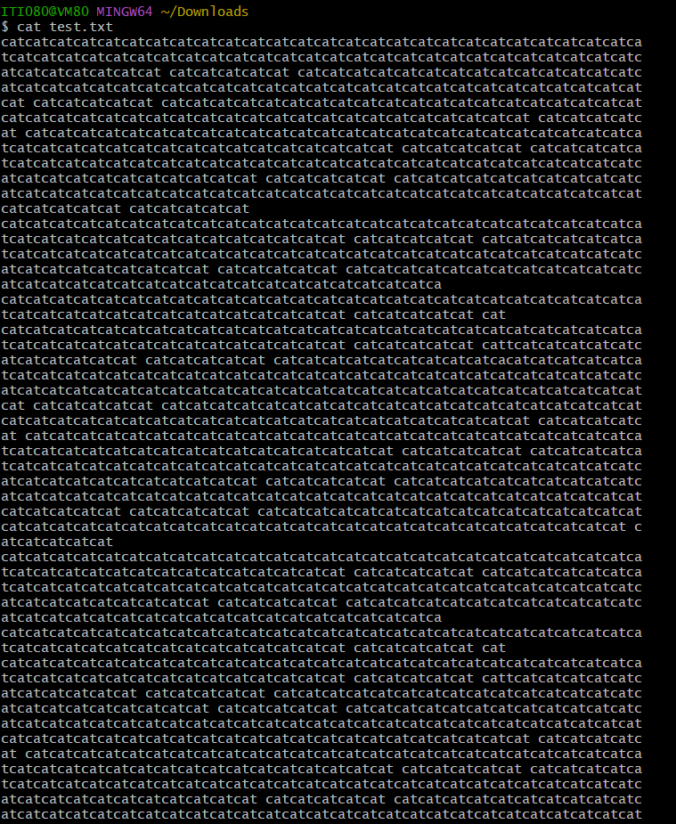

More:– Comfortable reading for large files

Displays the file one screen at a time, Starts from the top and waits for input and Ideal for navigating through long files without losing your place. 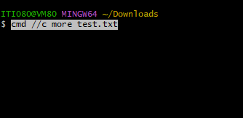

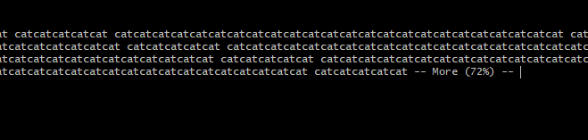

Less:-Newer and more powerful pager and lets you move forward and backward through the file.

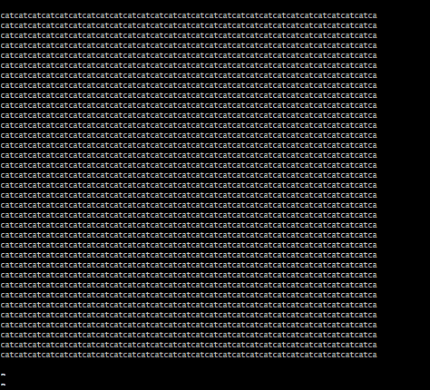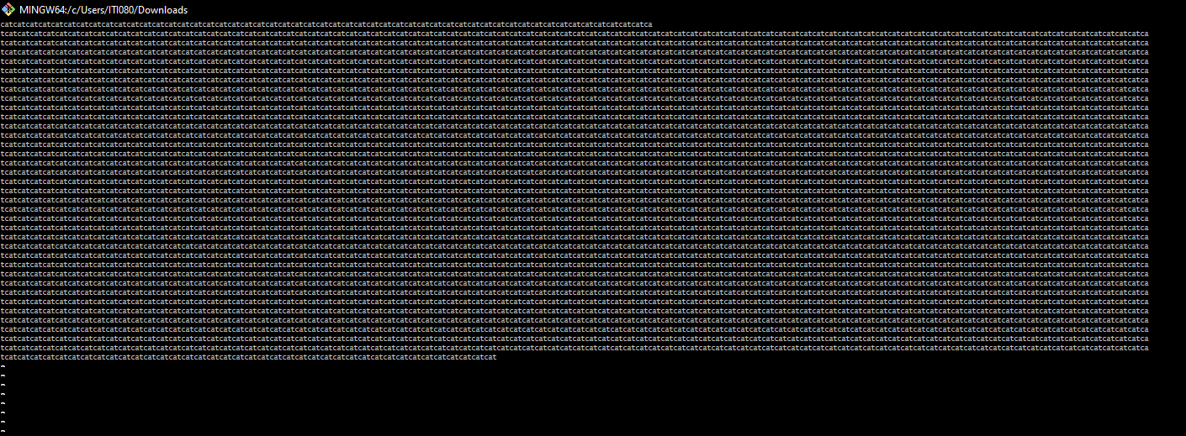

**Q3) What is the difference between rm and rmdir using man?**

rm — remove files or directories and Needs -r (recursive) to remove a directory and its contents.

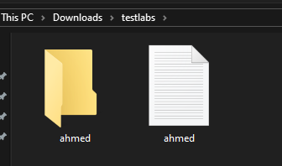 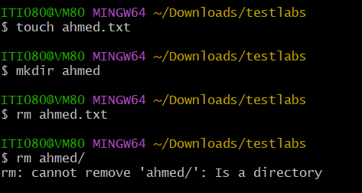

to remove a directory and its contents

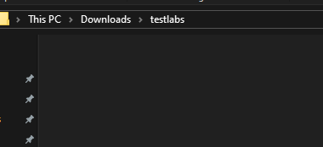

**rmdir** – *Remove empty directories*

Can remove multiple empty directories at once

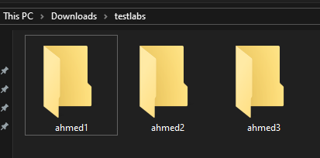

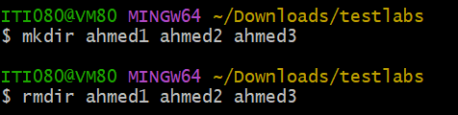

**Q4. Create the following hierarchy under your home directory:**

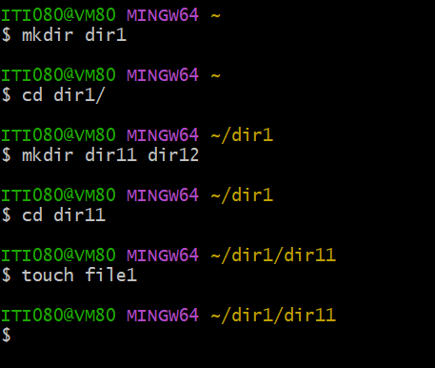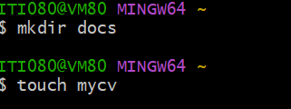

a-can’t remove because

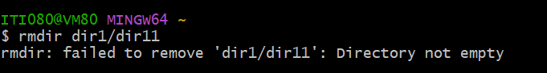

Use: rm -r dir1/dir11 (to remove it)

b-removes the target directory and its parent

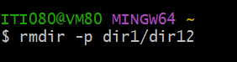

c-

absolute:

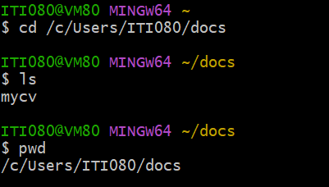

relative:

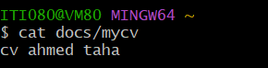

**5. Copy the /etc/passwd file to your home directory making its name is mypasswd.**

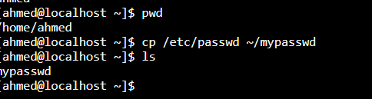

6.Rename this new file to be oldpasswd.

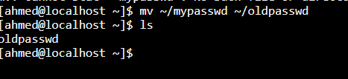

**7. You are in /usr/bin, list four ways to go to your home directory**

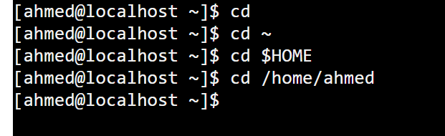

9-

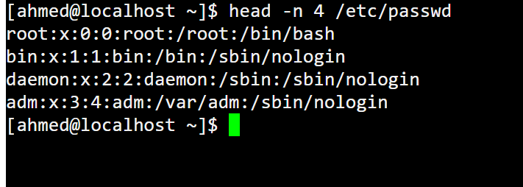

10-